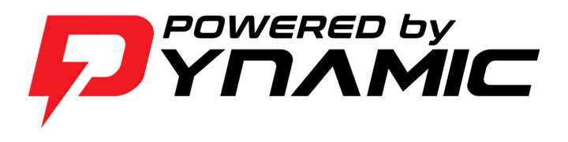

ECU CALIBRATION REQUEST SLIP
PLACE ECU INSIDE BOX WITH CALIBRATION SLIP!
NAME
PHONE NUMBER
EMAIL
YEAR
MAKE
MODEL
ECU MODEL
STOCK OEM
VORTEX
OTHER
FUEL TYPE
PUMP
VP / ETS
OTHER
COMBO
RIDING TYPE
MX/SX
TRAILS
FLAT TRACK
OTHER
ENGINE MODS
COMP RATIO
EXHAUST
INTAKE DESIGN
ANY OTHER NOTES
RETURN ADDRESS
The turnaround time is 3-7 business days
DYNAMIC USE ONLY
RECEIVED DATE: __________
COMPLETED AND SHIPPED DATE: ______________
SHIP TO: Dynamic Racing

+1 (704) 534-4406



www.DEF-Racing.com Info@DEF-Racing.com
609 Buford St.
Indian Trail, NC. 28079

